**Container Deployment Using Docker Swarm**

* Type the following command to check the docker version installed on lab:

**docker version**

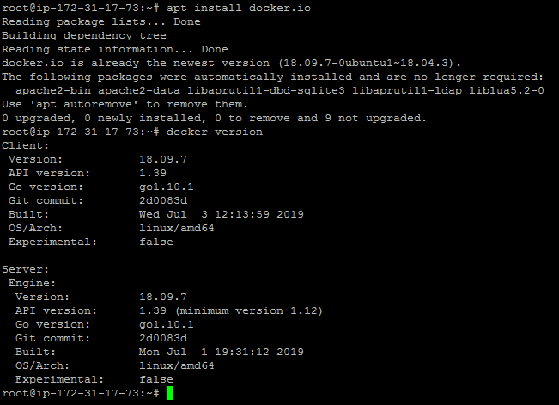

Building a custom Docker image to be deployed

* First, clone the Git repository on Docker host using the command below:

**git clone** [**https://github.com/Anuj1990/Docker.git**](https://github.com/Anuj1990/Docker.git)

* Run with docker build command to build a custom Docker image

**cd Docker**

**docker build -t phpcode . -f Dockerfile**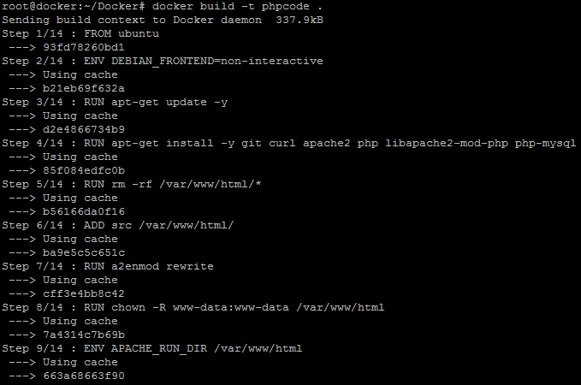

* Once the image is built, check if it is built properly or not. You can see a Docker image entry using Docker images command

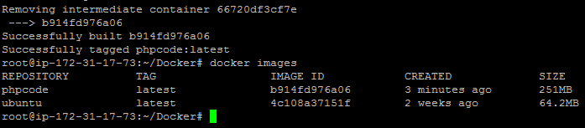

Initializing a Docker swarm cluster and deploying a container to the cluster

* First, we need to initialize Docker swarm using the set of commands given below:

**docker swarm init**

**docker node ls**

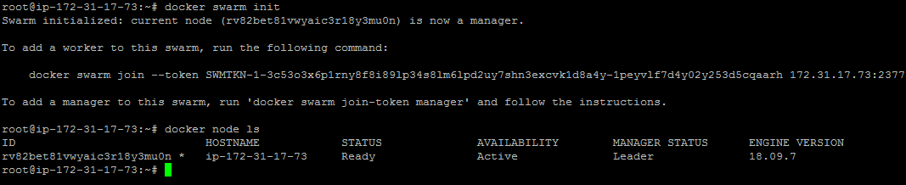

* Once the node is configured, deploy the custom Docker image on the Docker swarm cluster following the process shown below

**docker service create -p 80:80 --name webserver phpcode**

**docker service ls**

**curl localhost**

